Marks

………… Primary School THE FIRST SEMESTER TEST.
Name:………………………… Class: 4…. (School year:2012-2013).

I. Complete each word below each picture(4 pts). Hoàn thành từ dưới mỗi tranh

 |  |  | 
1. mor_ing | 2. ch_ ss | 3. Vietnam_ _ _ | 4. . Septemb_ _

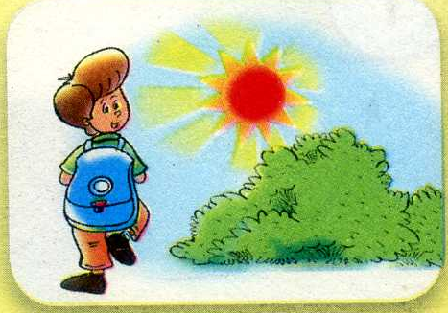

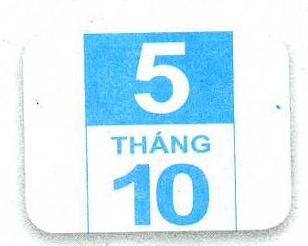

1/ morning 2/ chess 3/ Vietnamese 4/ September

II. Read and match(2 pts).Đọc và nối
1. How are you?
- Fine, thanks. A.

2. I go to school in the ______________.
B.

3. What’s the date today?
-It’s the fifth of October. C.

4. I’m from_______. D.

1…… 2..… 3..… 4……

1/

III. Select and circle the best answer A,B or C ( 2 pts ) Chọn và khoanh tròn đáp án đúng nhất A, B hay C
- ………………..subjects do you like ?
A. What B. Who C. How
- When do you………………Math?
A. sing B. have C. draw
- Would you like an ice – cream ?
A. Yes, I like B. No, thanks C. Yes, you would
- Can you ride a bike ?
- No, I can
- No, I can’t play football.
- Yes, I can

IV. Reorder the words to make sentences: (2 pts)Sắp xếp từ thành câu
- have / I / English / on / Tuesday
…………………………………………………………………………….
- like / you / milk / would / some ?
………………………………………………………………………………
1/ I have English on Tuesday.
2/ Would you like some milk?

